## Influential Software Engineer - CS3012

## 17326846|Patrick Byrne

*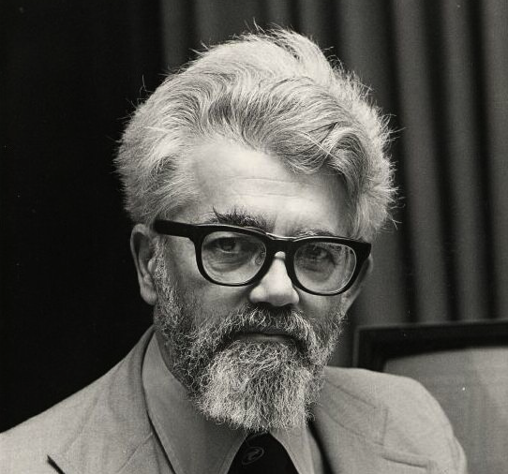John McCarthy*

1927-2011.

American/Irish Mathematician and Computer Scientist .

Follow of the Computer History Museum, 1999.

“Our ultimate objective is to make programs that learn from their experiences as effectively as humans do” – John McCarthy

John McCarthy, a pioneer in the field of Artificial intelligence. Developer of the Lisp language family. Influential in the design of ALGOL language, polarized time-sharing and garbage-collection.

Early Life and Education

John McCarthy Senior was a Kerry man raised in Cromane. He moved to London and met Ida Glatt from Lithuania. After briefly visiting Ireland they moved to Boston where in 1927, computer scientist and cognitive scientist, John McCarthy was born. During the Great Depression John’s father struggled to find employment and as a result had to relocate frequently. They eventually settled in Los Angeles.

McCarthy was exceptionally talented in mathematics and while at school in Belmont High School he taught himself college level maths from Caltech textbooks. This allowed him to skip the first two years of his undergraduate degree.

In 1944 he was accepted into Caltech. He graduated with a Bachelor of Science in Mathematics in 1948. John Von Neuman gave an inspirational talk in Caltech during McCarthy’s stay there, which seeded a thought in his mind that had a major influencing factor in his future career. McCarthy graduated in 1951.

Career

McCarthy began to teach mathematics in Dartmouth College. It was here that he held a conference in 1956 titled “Artificial Intelligence”, a term he coined.

In 1958 he moved to MIT where he was appointed assistant professor. He also set up an Artificial Intelligence Laboratory with Marvin Minsky.

As Minsky and McCarthy’s views of the future began to diverge, McCarthy left MIT and started, SAIL, the Stanford Artificial Intelligence Laboratory, which that came to be MIT’s competition.

Impact

McCarthy paved the way for the development of AI starting with his first conference in 1956 in Dartmouth. He coined the term Artificial Intelligence and held his own as one of the leading figures in the field for over 5 decades. He always believed in the importance of intelligent machines that can reason like humans, be capable of abstract thought, problem solve and self-improve. He wasn’t sure if this development would take 5 or 500 years, but he was determined and confident it would come.

In 1958 he invented LISP, the list processing language. It incorporated symbols as well as numbers and is still very relevant today in AI, robotics and a plethora of internet and scientific based services. It is influential in the detection of credit card fraud, airline scheduling as well as the phenomenon that is SIRI the iPhone voice recognition service.

He also invented “garbage collection” a very useful tool used by programmers with little computer memory. This made it much easier for many programmers and is still being used today. Garbage collection made it possible to make large LISP programs using little space.

While at MIT he played a very important role in the development of time-sharing systems where multiple users could have access simultaneously over a network. This is the pinnacle of the internet and the internet was an expansion of this idea.

In the 1960’s and 70’s, McCarthy’s Laboratory in Stanford elevated to new heights. It had a pivotal role in the breakthrough of computer systems mimicking many human attributes like vision, movement, listening and comprehending. He strongly encouraged inventions and invited the Homebrew Computer Club, an early computer Hobbyist group who played an influential role in the development in the microcomputer revolution and the rise of Silicon Valley. The group included two of Apple founding members, Steve Jobs and Steve Wozniak. In 1970 McCarthy presented a paper on the idea of the trade of good via computer, a prediction of the e-commerce we rely on so much today.

Awards and Honours

* Turing Award from the Association for Computing Machinery (1971).
* Kyoto Prize (1988).
* National Medal of Science (USA) in Mathematical, Statistical, and Computational Sciences (1990).
* Inducted as a Fellow of the Computer History Museum "for his co-founding of the fields of Artificial Intelligence (AI) and timesharing systems, and for major contributions to mathematics and computer science". (1999)
* Benjamin Franklin Medal in Computer and Cognitive Science from the Franklin Institute (2003).
* Inducted into IEEE Intelligent Systems' AI's Hall of Fame (2011), for the "significant contributions to the field of AI and intelligent systems".
* Named as one of the 2012 Stanford Engineering Heroes.

John died at the age of 84 in his home on October 24, 2011. His memory lives on through his third wife, Carolyn Talcott and his children Sarah, Susan and Timothy. He will also be remembered for his incredibly influential software engineering career and the manner in which he greatly impacted and contributed to society in many spheres.

## References:

* <https://www.independent.co.uk/news/obituaries/john-mccarthy-computer-scientist-known-as-the-father-of-ai-6255307.html>
* <https://www.irishtimes.com/life-and-style/people/leading-academic-who-coined-the-term-artificial-intelligence-1.11243>
* <https://www.britannica.com/biography/John-McCarthy>
* <https://www.computerhistory.org/fellowawards/hall/john-mccarthy/>
* <https://en.wikipedia.org/wiki/John_McCarthy_(computer_scientist)>